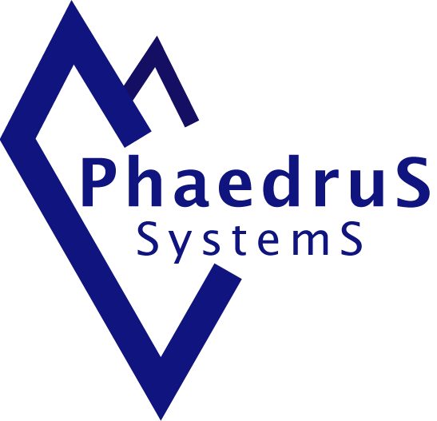
BIOGRAPHY

Eur Ing Chris Hills
Technical Director
Phaedrus Systems
Chris Hills grew up in an engineering household and has never escaped from engineering. His career spans periods with the RAF, electronics companies and in distribution, working as a technician, team leader, project leader and manager. He has covered all phases of the product life cycle, from specification, through design, implementation, manufacturing, sales and marketing and support.
Real world hardware experience covers both analogue and digital domains. Software skills include development in various languages on various systems, ranging from large Unix-based comms projects to smart cards. Chris also has experience in leading technical teams and projects, gained from working on military systems (both air and ground based) at the sharp end and in development, on experimental systems in safety critical industrial control, in maintenance and reverse engineering.
He has translated that experience into print with a regular columns in Embedded Systems Engineering, MTE and other publications. He is a prolific book reviewer, has created the QuEST series of papers on embedded C, debuggers, testing and RTOS and is frequent contributor of papers and keynotes at technical conferences.
Chris Hills has been a member if the ISO/BSI C and C++ Language Panels since 1999 and was the convener of the C panel from 2000 to 2004. He has also sat on the IEC 61508-3 Panel. Additionally, he has been part of MISRA-C since 1998 and been on the MISRA-C Technical Board since its inception. He is also on the Industrial liaison board for several UK Universities
Chris is a Eur Ing and Chartered Engineer, a Member of The Institution of Engineering and Technology (MIET), a Member of the British Computer Society (MBCS) a Fellow of the Royal Society For the Encouragement of Arts, Commerce and Manufacture (FRSA) and a Fellow of the Royal Geographical Society (FRGS).
June 2015

